Name: R Priya Dharshini
Roll: CH.SC.U4CYS25026

ACTIVITY – 3
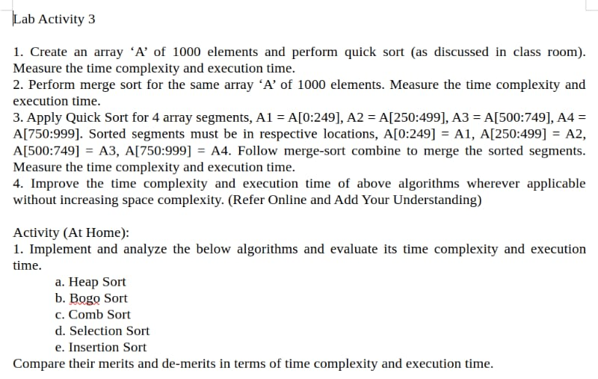
ANSWER 1:
Program
#include<stdio.h>
#include<stdlib.h>
#include<time.h>
#include<math.h>

void swap(int *a,int *b)
{
int temp=*a;
*a=*b;
*b=temp;
}

int partition(int arr[],int low,int high)
{
int pivot=arr[high];
int i=low-1;

for(int j=low;j<high;j++)
{
if(arr[j]<=pivot)
{
i++;
swap(&arr[i],&arr[j]);
}
}

swap(&arr[i+1],&arr[high]);
return i+1;
}

void quickSort(int arr[],int low,int high)
{
if(low<high)
{
int pi=partition(arr,low,high);

quickSort(arr,low,pi-1);
quickSort(arr,pi+1,high);
}
}

int main()
{
srand(time(NULL));

int a[1000];

for(int i=0;i<1000;i++)
a[i]=rand()%1000;

printf("Before Sorting (First 20 Elements):\n");
for(int i=0;i<20;i++)
printf("%d ",a[i]);

clock_t start,end;

start=clock();
quickSort(a,0,999);
end=clock();

printf("\n\nAfter Sorting (First 20 Elements):\n");
for(int i=0;i<20;i++)
printf("%d ",a[i]);

double timc=((double)(end-start))/CLOCKS_PER_SEC;

int a1[4000];

for(int i=0;i<4000;i++)
a1[i]=rand()%4000;

start=clock();
quickSort(a1,0,3999);
end=clock();

double timc1=((double)(end-start))/CLOCKS_PER_SEC;

printf("\n\nExecution Time (1000 Elements) : %lf seconds",timc);
printf("\nExecution Time (4000 Elements) : %lf seconds",timc1);

printf("\nRatio (Experimental) : %lf",timc1/timc);

double t1=1000*(log(1000)/log(2));
double t2=4000*(log(4000)/log(2));

printf("\nRatio (Theoretical) : %lf",t2/t1);

printf("\n\nTime Complexity:");
printf("\nBest Case : O(n log n)");
printf("\nAverage Case : O(n log n)");
printf("\nWorst Case : O(n^2)");

return 0;
}
Output
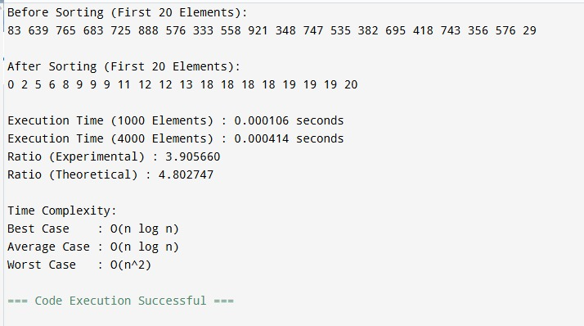

ANSWER 2:
Program
#include<stdio.h>
#include<stdlib.h>
#include<time.h>
#include<math.h>

void merge(int arr[],int low,int mid,int high)
{
int temp[4000];
int i=low,j=mid+1,k=low;

while(i<=mid && j<=high)
{
if(arr[i]<=arr[j])
temp[k++]=arr[i++];
else
temp[k++]=arr[j++];
}

while(i<=mid)
temp[k++]=arr[i++];

while(j<=high)
temp[k++]=arr[j++];

for(i=low;i<=high;i++)
arr[i]=temp[i];
}

void mergeSort(int arr[],int low,int high)
{
if(low<high)
{
int mid=(low+high)/2;

mergeSort(arr,low,mid);
mergeSort(arr,mid+1,high);

merge(arr,low,mid,high);
}
}

int main()
{
srand(time(NULL));

int a[1000];

for(int i=0;i<1000;i++)
a[i]=rand()%1000;

printf("Before Sorting (First 20 Elements):\n");
for(int i=0;i<20;i++)
printf("%d ",a[i]);

clock_t start,end;

start=clock();
mergeSort(a,0,999);
end=clock();

printf("\n\nAfter Sorting (First 20 Elements):\n");
for(int i=0;i<20;i++)
printf("%d ",a[i]);

double timc=((double)(end-start))/CLOCKS_PER_SEC;

int a1[4000];

for(int i=0;i<4000;i++)
a1[i]=rand()%4000;

start=clock();
mergeSort(a1,0,3999);
end=clock();

double timc1=((double)(end-start))/CLOCKS_PER_SEC;

printf("\n\nExecution Time (1000 Elements) : %lf seconds",timc);
printf("\nExecution Time (4000 Elements) : %lf seconds",timc1);

printf("\nRatio (Experimental) : %lf",timc1/timc);

double t1=1000*(log(1000)/log(2));
double t2=4000*(log(4000)/log(2));

printf("\nRatio (Theoretical) : %lf",t2/t1);

printf("\n\nTime Complexity:");
printf("\nBest Case : O(n log n)");
printf("\nAverage Case : O(n log n)");
printf("\nWorst Case : O(n log n)");

return 0;
}
Output
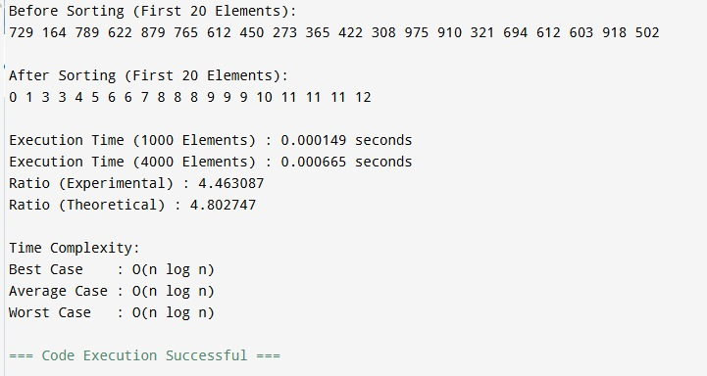

ANSWER 3:
Program
#include<stdio.h>
#include<stdlib.h>
#include<time.h>

void swap(int *a,int *b)
{
int temp=*a;
*a=*b;
*b=temp;
}

int partition(int arr[],int low,int high)
{
int pivot=arr[high];
int i=low-1;

for(int j=low;j<high;j++)
{
if(arr[j]<=pivot)
{
i++;
swap(&arr[i],&arr[j]);
}
}

swap(&arr[i+1],&arr[high]);
return i+1;
}

void quickSort(int arr[],int low,int high)
{
if(low<high)
{
int pi=partition(arr,low,high);

quickSort(arr,low,pi-1);
quickSort(arr,pi+1,high);
}
}

void merge(int arr[],int low,int mid,int high)
{
int temp[1000];
int i=low,j=mid+1,k=low;

while(i<=mid && j<=high)
{
if(arr[i]<=arr[j])
temp[k++]=arr[i++];
else
temp[k++]=arr[j++];
}

while(i<=mid)
temp[k++]=arr[i++];

while(j<=high)
temp[k++]=arr[j++];

for(i=low;i<=high;i++)
arr[i]=temp[i];
}

int main()
{
srand(time(NULL));

int a[1000];

for(int i=0;i<1000;i++)
a[i]=rand()%1000;

printf("Before Sorting (First 20 Elements):\n");
for(int i=0;i<20;i++)
printf("%d ",a[i]);

clock_t start,end;

start=clock();

quickSort(a,0,249);
quickSort(a,250,499);
quickSort(a,500,749);
quickSort(a,750,999);

merge(a,0,249,499);
merge(a,500,749,999);
merge(a,0,499,999);

end=clock();

printf("\n\nAfter Sorting (First 20 Elements):\n");
for(int i=0;i<20;i++)
printf("%d ",a[i]);

double timc=((double)(end-start))/CLOCKS_PER_SEC;

printf("\n\nExecution Time : %lf seconds",timc);

printf("\n\nTime Complexity:");
printf("\nQuick Sort : O(n log n)");
printf("\nMerge : O(n)");
printf("\nOverall : O(n log n)");

return 0;
}
Output
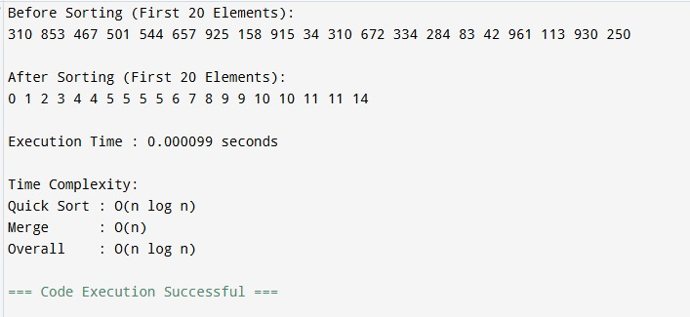

ANSWER 4:
- Choose a better pivot (Random Pivot or Median-of-Three Pivot) to avoid highly unbalanced partitions.

- Use Insertion Sort for very small sub-arrays (less than 10–20 elements).

- Avoid unnecessary recursive calls by checking the partition size.

- Apply Tail Recursion Optimization to reduce recursive overhead.
- Sort the smaller partition first, which reduces the recursion depth.

ANSWER for Activity(At Home-1):
Program
/* Sorting Program
* Algorithms:
* 1. Heap Sort
* 2. Bogo Sort (uses first 8 elements only)
* 3. Comb Sort
* 4. Selection Sort
* 5. Insertion Sort
*/

#include<stdio.h>
#include<stdlib.h>
#include<time.h>

#define SIZE 1000
#define BOGO_SIZE 8

void swap(int *a,int *b){int t=*a;*a=*b;*b=t;}

void fillRandom(int a[],int n){
for(int i=0;i<n;i++) a[i]=rand()%10000;
}

void printArray(int a[],int n){
for(int i=0;i<n;i++){
printf("%5d ",a[i]);
if((i+1)%20==0) printf("\n");
}
printf("\n");
}

/* Heap Sort */
void heapify(int a[],int n,int i){
int largest=i,l=2*i+1,r=2*i+2;
if(l<n&&a[l]>a[largest]) largest=l;
if(r<n&&a[r]>a[largest]) largest=r;
if(largest!=i){
swap(&a[i],&a[largest]);
heapify(a,n,largest);
}
}
void heapSort(int a[],int n){
for(int i=n/2-1;i>=0;i--) heapify(a,n,i);
for(int i=n-1;i>0;i--){
swap(&a[0],&a[i]);
heapify(a,i,0);
}
}

/* Selection Sort */
void selectionSort(int a[],int n){
for(int i=0;i<n-1;i++){
int min=i;
for(int j=i+1;j<n;j++)
if(a[j]<a[min]) min=j;
swap(&a[i],&a[min]);
}
}

/* Insertion Sort */
void insertionSort(int a[],int n){
for(int i=1;i<n;i++){
int key=a[i],j=i-1;
while(j>=0&&a[j]>key){
a[j+1]=a[j];
j--;
}
a[j+1]=key;
}
}

/* Comb Sort */
void combSort(int a[],int n){
int gap=n;
int swapped=1;
while(gap!=1||swapped){
gap=(gap*10)/13;
if(gap<1) gap=1;
swapped=0;
for(int i=0;i+gap<n;i++){
if(a[i]>a[i+gap]){
swap(&a[i],&a[i+gap]);
swapped=1;
}
}
}
}

/* Bogo Sort */
int sorted(int a[],int n){
for(int i=1;i<n;i++)
if(a[i-1]>a[i]) return 0;
return 1;
}
void shuffle(int a[],int n){
for(int i=0;i<n;i++){
int j=rand()%n;
swap(&a[i],&a[j]);
}
}
void bogoSort(int a[],int n){
while(!sorted(a,n))
shuffle(a,n);
}

void complexity(int ch){
printf("\nTime Complexity\n");
switch(ch){
case 1: printf("Best: O(n log n)\nAverage: O(n log n)\nWorst: O(n log n)\nSpace: O(1)\n"); break;
case 2: printf("Best: O(n)\nAverage: O(n*n!)\nWorst: Infinite\nSpace: O(1)\n"); break;
case 3: printf("Best: O(n log n)\nAverage: O(n^2)\nWorst: O(n^2)\nSpace: O(1)\n"); break;
case 4: printf("Best: O(n^2)\nAverage: O(n^2)\nWorst: O(n^2)\nSpace: O(1)\n"); break;
case 5: printf("Best: O(n)\nAverage: O(n^2)\nWorst: O(n^2)\nSpace: O(1)\n"); break;
}
}

int main(){
int a[SIZE],ch;
srand(time(NULL));

do{
fillRandom(a,SIZE);

printf("1. Heap Sort\n");
printf("2. Bogo Sort (8 elements)\n");
printf("3. Comb Sort\n");
printf("4. Selection Sort\n");
printf("5. Insertion Sort\n");
printf("0. Exit\n");
printf("Enter choice: ");
scanf("%d",&ch);

if(ch==0) break;

printf("\nUnsorted Array (first 100 elements)\n");
if(ch==2) printArray(a,BOGO_SIZE);
else printArray(a,100);

clock_t start=clock();

switch(ch){
case 1: heapSort(a,SIZE); break;
case 2: bogoSort(a,BOGO_SIZE); break;
case 3: combSort(a,SIZE); break;
case 4: selectionSort(a,SIZE); break;
case 5: insertionSort(a,SIZE); break;
default: printf("Invalid Choice\n"); continue;
}

clock_t end=clock();

printf("\nSorted Array\n");
if(ch==2) printArray(a,BOGO_SIZE);
else printArray(a,100);

printf("\nExecution Time: %.6f seconds\n",
(double)(end-start)/CLOCKS_PER_SEC);

complexity(ch);

}while(1);

return 0;
}
Output
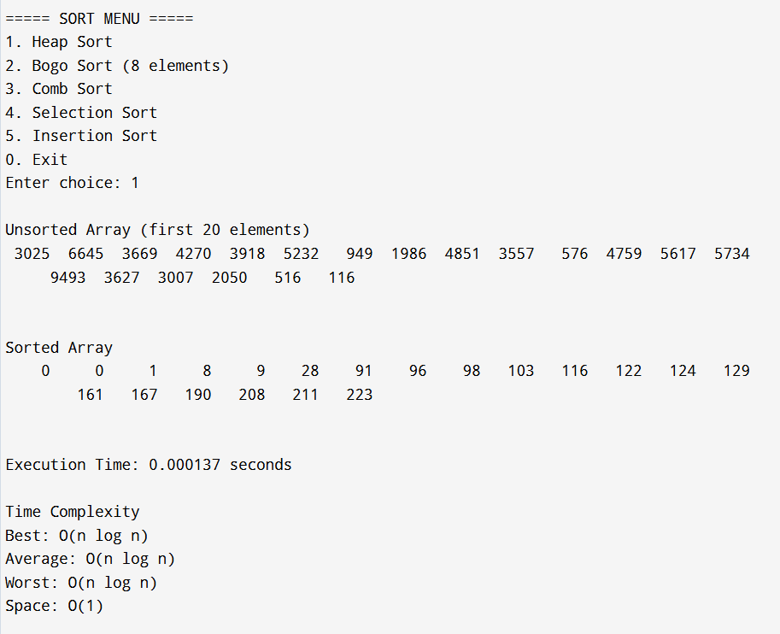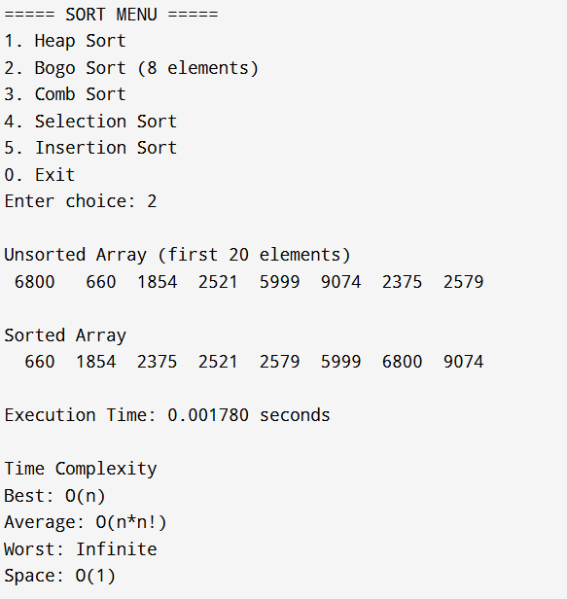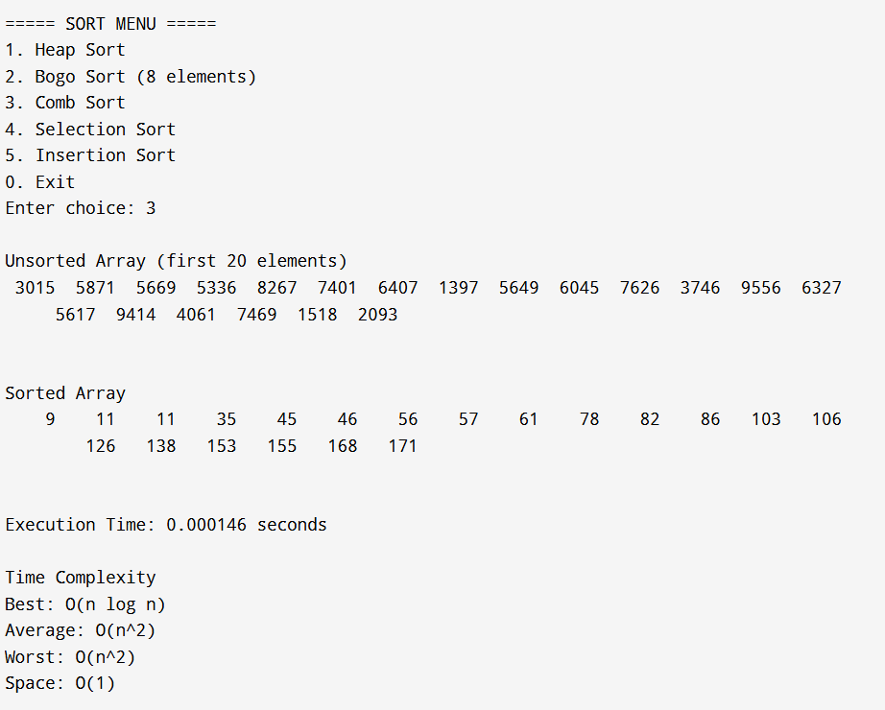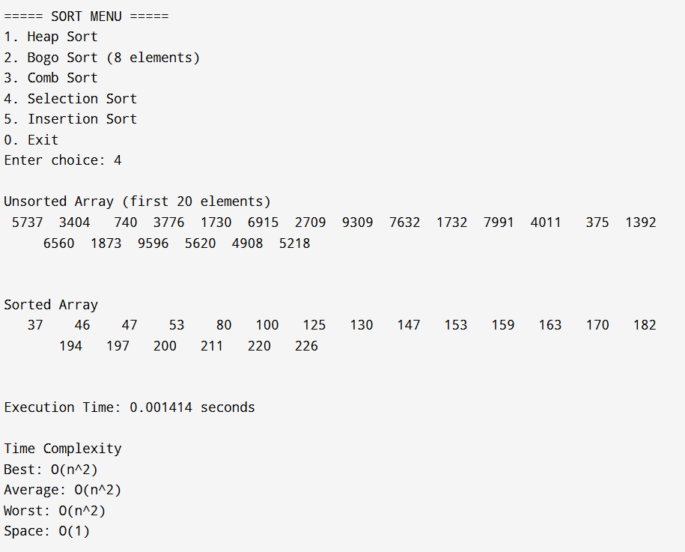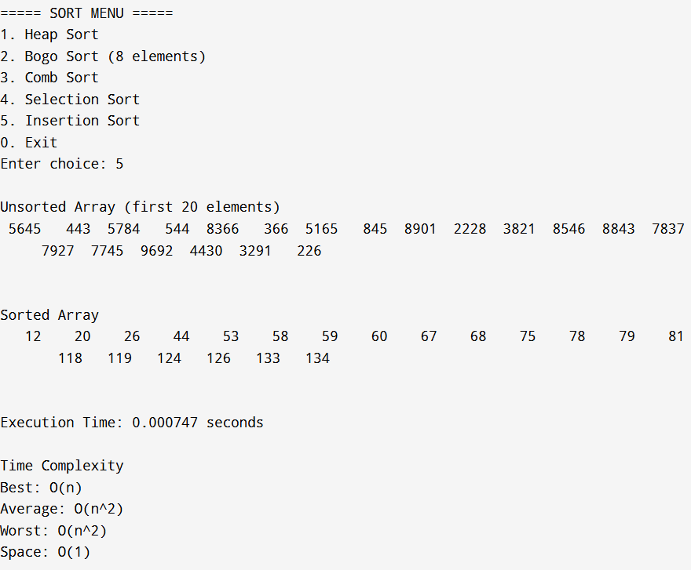

Comparison of Sorting Algorithms
Comparison of merits and de-merits in terms of time complexity and execution time.
Algorithm | Time Complexity | Execution Time | Merits | Demerits
Heap Sort | Best: O(n log n)  Average: O(n log n)  Worst: O(n log n) | Fast and consistent for large datasets. | Guaranteed O(n log n), in-place, suitable for large datasets. | Not stable; usually slower than Quick Sort in practice.
Bogo Sort | Best: O(n)  Average: O(n × n!)  Worst: Infinite/Unbounded | Extremely slow; practical only for 5–8 elements. | Very simple; useful for educational purposes. | Impractical for real applications due to enormous execution time.
Comb Sort | Best: O(n log n)  Average: ≈ O(n²)  Worst: O(n²) | Faster than Bubble Sort but slower than Heap Sort. | Simple; improves Bubble Sort by eliminating turtles. | Not stable; still inefficient for very large datasets.
Selection Sort | Best: O(n²)  Average: O(n²)  Worst: O(n²) | Slow for large datasets. | Simple, minimum swaps, O(1) extra space. | Always O(n²); not suitable for large datasets.
Insertion Sort | Best: O(n)  Average: O(n²)  Worst: O(n²) | Very fast for small/nearly sorted arrays. | Stable, simple, efficient for small datasets. | Slow for large random datasets.

Conclusion
Heap Sort is the best choice for large datasets because it guarantees O(n log n) time in all cases. Insertion Sort is efficient for small or nearly sorted arrays. Selection Sort is simple but inefficient for large data. Comb Sort improves over Bubble Sort but remains quadratic in the worst case. Bogo Sort is intended only for educational demonstrations due to its extremely poor execution time.

